**MiWay Client reviews on hello peter**

To automate a Report for five star and one star client reviews on hello Peter.

This solution will enable business users to have a clear view of all client complaints and praises which is (Five star and one star Ratings) without interacting directly with the web Application (Hello Peter) which could be tedious

1. Robot to access Internet explorer application as follow = Robot will double click on the following link

<https://www.hellopeter.com/>

1. The following screen will pop up .Robot will click on Sign In



1. The following screen will pop up.

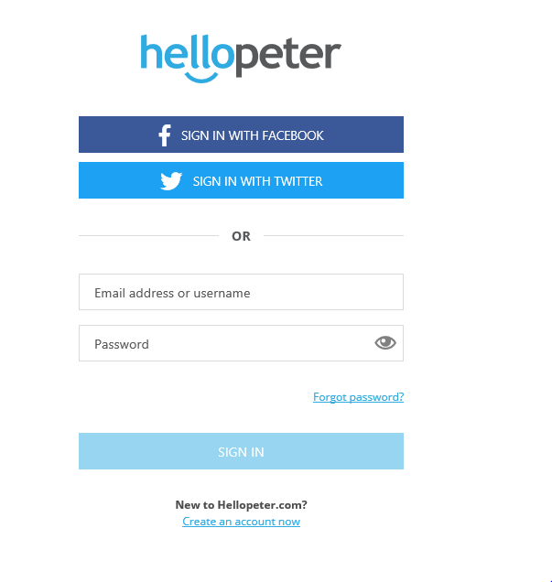

4. Robot will enter email address in line next to “email address or username” = Robot will press Tab once = Robot would enter password provided into the line next to “Password” and press enter.

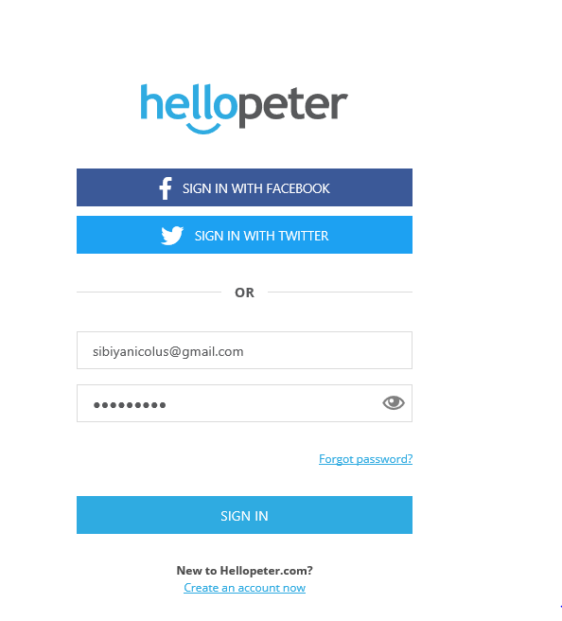

5. The following screen appears



6. Robot will click the MiWay Icon



7. The following screen appears

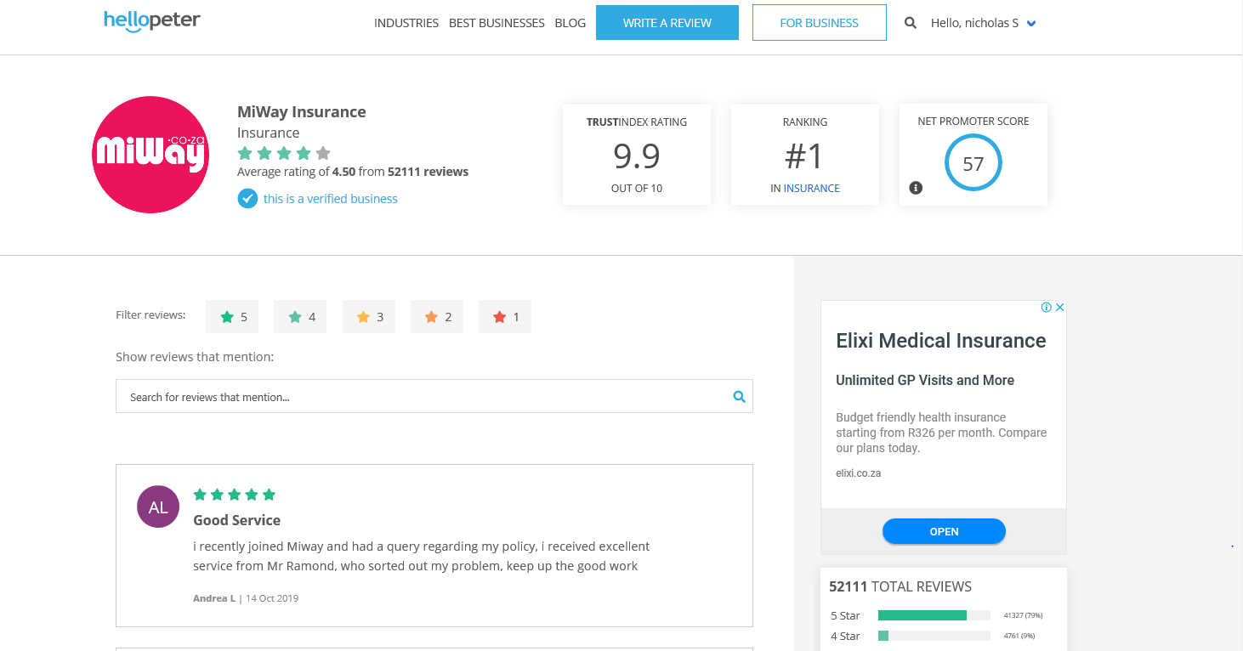

8. Robot will click the 5 star



9. After clicking on the “5 star” button, all of the “5 star” reviews will appear.

10. The robot will copy all reviews pertaining to the “5 star rating”.

11. All reviews will be copied and pasted to an excel specifically in the “5 star” tab.

The above information will be pasted in the excel in the below format.

1st column = Subject

2nd column = client Review

3rd column = client Name and date of review.

N:B The robot will only extract information for the current day, other dates prior will be excluded.

12. When the Robot has completed the five star rating it will then unselect “5 star” and select “1 star” and then repeat the process



13. When the robot has completed everything it will click the drop down highlighted to logoff, if the logout button does not appear robot will exit internet explore

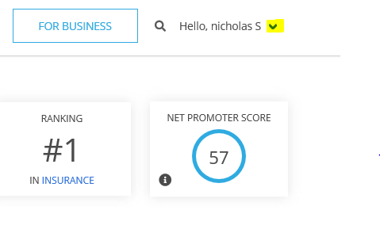

**N:B The user will go and check the excel to find all five star and one star reviews for the day**